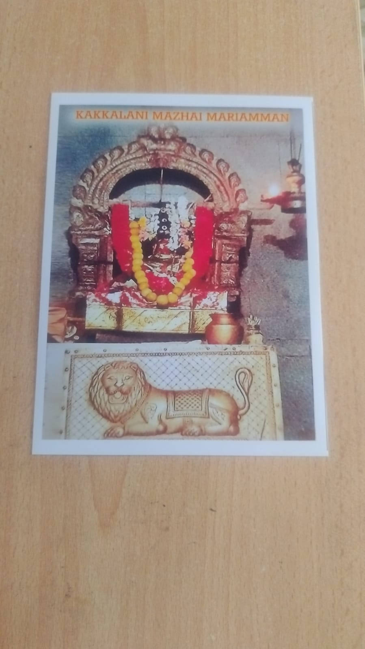
Mazhai Mariamman Temple
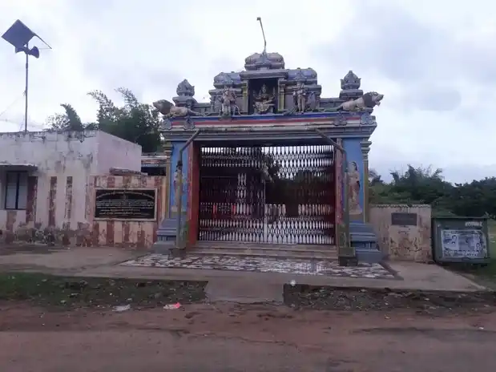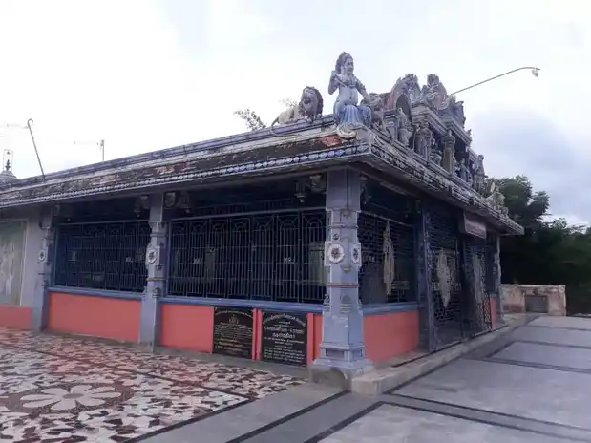

Mazhai Marriamman Koil is situated in about 100 meters from Sivan Koil, towards east.
Significance of this temple and deity are already detailed in Page detailing about Kakkalani Village as well as Gnanambal Sametha Kalahastishwarar temple.
This temple is maintained by a separate committee in the village and daily pooja performed by poojari staying close to the temple.
We also coordinate for our donors to do seva like archana / abishekam in this temple.
Kumbabishekam for this temple was done recently in year 2025.

